NOTE: Staff has revised the text in this case to only show the text that will be modified with the B1 Expansion project. All other text to be modified has been moved to the text amendment where the Town is addressing compliance with General Statute 160D. The text in yellow below shows the new framework that the UDO will be updated to within the “160D” text amendment. Please call the Planning and Inspections Department for more information.
Text in blue underline is new text while text to be deleted is shown in red strikethrough.

…
Part I Establishment of Zoning Districts and District Standards

14.01 Enumeration and Description of Districts
14.01.01 In order to regulate the height, size of buildings, the intensity and location of land usage, areas of livability space, provide for an improved environment, and to promote the health, safety, and general welfare of its citizens, the Town of Boone is divided into zoning districts. Note: district titles are intended to convey general land use but the specific standards for each district determine the actual regulations applicable to a particular site.
14.01.02 There are three types of zoning districts: general use districts, overlay districts and conditional districts.
- General use districts are those in which a variety of uses are permitted. The general use districts established in this article are classified as follows:
R1 | Single-Family Residential District
R1S | Small Home Residential District
R1A | Single-Family Residential with Accessory Dwelling District
RR | Residential Rehabilitation Residential District
R2 | Two-Family Residential District
R3 | Multiple-Family Residential District
R4 | Two-Family/Manufactured Home Residential District
R5 | 55+ Housing Residential District
RA | Residential Agricultural District
MH | Manufactured Home Park District
B1 | Central Business District
B2 | Neighborhood Business District
B3 | General Business District
OI | Office Institutional District
WD | Wellness District
M1 | Manufacturing District
U1 | University District
U1 | Educational District
E2 | Educational District
E3 | Educational District
E4 | Educational Child Daycare District
- Overlay districts are those districts that overlap one or more general use districts and contain standards in addition to the underlying general use or conditional district zoning standards. Where requirements conflict, overlay district standards supersede general use district standards. The overlay districts established in this article are classified as follows:
Special Flood Hazard Area (SFHA)
Watershed Protection District
Corridor District
Neighborhood Conservation District (NCD)
Viewshed Protection District
Historic Districts
- A Conditional District (CD) is a zoning district in which the use and development of a property pursuant to a site-specific vesting plan is approved through the legislative process pursuant to Article 9 of this Ordinance. A CD utilizes a proposed general use zoning district, is limited to the authorized uses and development standards mandated within that district, and may be subjected to conditions that make the development more desirable.
14.01.03 Split Zone:
- When a development is proposed on land with more than one zoning classification, the elements of the development, including but not limited to parking, recreation and storage, must be located on those portions of the development with zoning designations which allows the use as a principal use or is otherwise specifically authorized. Notwithstanding this prohibition all portions of the site may be used to satisfy the requirements of Section 14.03 unless otherwise prohibited.
- Where a lot is located in more than one zoning district, the appropriate land use intensity ratios shall be applied individually to each portion of the gross land area located within the different districts.
14.01.04 Official Zoning Map
- There shall be a map known and designated as the Official Zoning Map, which shall show the boundaries of all zoning districts within the town’s planning jurisdiction.
- The Official Zoning Map is adopted and incorporated herein by reference. Amendments to this map shall be made and posted in accordance with Article 9.
- A copy of the current Official Zoning Map shall be available for public inspection in the Planning and Inspections Department.

14.02 Use Information
    - Use Table Guidance. Each zoning district enumerated in Part II of this article contains a list of uses permissible in the district. Review Appendix B to view comparative tables that list all uses allowed within the zoning districts enumerated in Section 14.01.
- Permitted (P): A “P” in a Table of Principal Uses, Table of Accessory Uses, and Table of Temporary Uses indicates that a use is allowed by right in the respective district unless the use is subject to a transitional zone (see 6.02.02). Such uses are subject to all applicable requirements of this Ordinance but do not have additional requirements which are specific to the use in accordance with this Article.
- Permitted Subject to Limitations (L): An “L” in a Table of Principal Uses, Table of Accessory Uses, and Table of Temporary Uses indicates that a use is allowed by right in the respective district unless the uses is subject to a transitional zone (see 6.02.02), provided that the use meets the normal requirements of the Ordinance plus additional requirements designed to address the specific impacts of the use. A cross-reference in the “Reference” column of the Table for a permitted use with an “L” is intended to direct the reader to a Section(s) which has special importance to the use, but it does not limit the applicability of other Sections.
- Special Use Permit Required (S): An “S” in the Table of Principal Uses, Table of Accessory Uses, and Table of Temporary Uses indicates that a use is allowed only with a Special Use Permit in the respective district. A cross-reference in the “Reference” column of the Table for a permitted use with an “S” is intended to direct the reader to a Section which has special importance to the use, but it does not limit the applicability of other Sections.
- Conditional District (CD): A “CD” in a Table of Principal Uses, Table of Accessory Uses, and Table of Temporary Uses indicates that a use is allowed only with a Conditional District zoning approval in the respective district. A cross-reference in the “Reference” column of the Table for a permitted use with a “CD” is intended to direct the reader to a Section which has special importance to the use, but it does not limit the applicability of other Sections.
- Not Permitted (Blank Cell): A blank cell in a Table of Principal Uses, Table of Accessory Uses, and Table of Temporary Uses indicates that a uses in not allowed in the respective district.
- Transitional Zones: Transitional zones attach to specific uses within the tables and are designed to address the predictable negative impacts of certain uses on protected residential districts and therefore have additional standards which must be met. A proposed use subject to a transitional zone must be approved by a Special Use Permit or in a Conditional District. A superscript “Tn” in the Table of Principal Uses, Table of Accessory Uses or the Table of Temporary Uses denotes the specified use in the specified district is subject to a transitional zone, where “n” represents the size, in feet, of the transitional zone, measured from the boundary of the protected district. However, in the any of the protected districts, the distance is measured from the protected lot rather than the protected zone. See Subsection 6.02.02 for full transitional zone requirements.
- Use Nomenclature: Each use listed in the tables is more fully defined in Article 34 Definitions. The nomenclature of each use within the tables is for identification purposes only.
14.02.02 Accessory Uses:
- An accessory use must be:
- Clearly incidental to and customarily found in connection with a principal structure or use; and
- Subordinate to and serve a principal structure or use; and
- Subordinate in area, extent, or purpose to the principal structure or use served; and
- Located on the same property as the principal structure
- A use which is not permitted as a principal use in a zoning district cannot be allowed as an accessory use in that district unless it is specifically listed in the Table of Accessory Uses.
- When a development is proposed on land with more than one zoning classification, any accessory use must be located on those portions of the development with zoning designations which allows the use as principal use or is authorized by the Table of Accessory Uses.

14.02.03 Uses Not Requiring Permits
- Notwithstanding any other provisions of this ordinance, no zoning or special use permit is necessary for the following uses:
- Public streets or sidewalks.
- Electric power, telephone, telegraph, cable television, gas, water and sewer lines, wires or pipes, together with supporting poles or structures, located within a public right-of-way with the permission of the owner.
- Utility facilities located within a public right-of-way with the permission of the owner.
    - Combination Uses
- A combination use may only be authorized if all proposed principal uses are permissible in the zoning district for which it is proposed.
- A combination use must be authorized by a special use permit if any of the permissible uses requires a special use permit.
- A combination use has special rules regarding landscaping (See Article 31).
14.02.05 More Specific Use Controls
- When two use classifications in the Table of Principal Uses describe a particular activity, the more specific description shall control.
14.02.06 Unlisted Uses: Any use not permitted, prohibited, or restricted by this Ordinance is an “unlisted use” that shall only be permitted if approved by the Planning Director pursuant to the following provisions:
- Procedure for Evaluating Unlisted Uses: Where a particular use category or use type is not specifically allowed under this Ordinance or is also not prohibited or restricted by this Ordinance, the Planning Director may permit the use category or type if the criteria of Subsection 14.02.06(B) below are met. The Planning Director shall give due consideration to the intent of this Ordinance concerning the district(s), involved, the character of the uses specifically identified, and the character of the use(s) in question.
- Criteria for Evaluating Unlisted Uses: In order to determine that the prosed uses(s) has an impact that is similar in nature, function, and duration to the other uses allowed in a specific zoning district, the Planning Director shall assess all relevant characteristics of the proposed use, including but not limited to the following:
- The volume and type of sales, retail, wholesale; size and type of items sold and nature of inventory on the premises;
- Any processing done on the premises, including assembly, manufacturing, warehousing, shipping, distribution; any dangerous, hazardous, toxic, or explosive materials used in the processing; and
- The nature and location of storage and outdoor display of merchandise; enclosed, open, inside or outside the principal building; and predominant types of items stored (such as business vehicles, work-in-process, inventory, and merchandise, construction materials, scrap and junk, and raw materials including liquids and powders); and
- The type, size and nature of buildings and structures; and
- The number and density of employees and customers per unit area of site in relation to business hours and employment shifts; and
- Transportation requirements, including the modal split for people and freight, by volume type and characteristic of traffic generation to and from the site, trip purposes and whether trip purposes can be shared by other uses on the site; and
- Parking requirements, turnover and generation, ratio of the number of spaces required per unit area or activity, and the potential for shared parking with other uses; and
- The amount and nature of any nuisances generated on the premises, including but not limited to noise, smoke, odor, glare, vibration, radiation and fumes; and
- Any special public utility requirements for serving the proposed use, including but not limited to water supply, wastewater output, pre-treatment of wastes and emissions required or recommended, and any significant power structures and communications towers or facilities; and
- The impact on adjacent properties created by the proposed use will not be greater than that of other uses in the zoning district.
C. Determination of Unlisted Use(s) by the Planning Director: All determinations by the Planning Director made pursuant to this section shall be in writing. In making the determination described in this section, the Planning Director shall initiate an amendment to this Ordinance if the particular use or category of use(s) is likely to be common or to recur frequently, or if the omission is likely to lead to public uncertainty and confusion.

14.03 Intensity Standards
14.03.01 Unless otherwise provided in this Ordinance, development shall comply with the intensity regulations set forth for the district. Review Appendix B to view comparative tables that comprehensively list the intensity regulations set forth for the zoning districts enumerated in Section 14.01.
- Subject to the other provisions of this Ordinance, if (i) any portion of a tract lies within an area designated on any officially adopted Town plan as part of a proposed public park, greenway, or bikeway, and (ii) before the tract is developed, the owner of the tract, with the concurrence of the Town, dedicates to the Town that portion of the tract so designated, then, when the remainder of the tract is developed for residential purposes, the permissible density at which the remainder may be developed shall be calculated by regarding the dedicated portion of the original lot as if it were still part of the lot proposed for development.
14.03.02 Minimum Gross Land Area
    - When a lot is located in more than one zoning district, the minimum square footage of the lot shall be the sum of the square footage derived by multiplying the minimum square footage required for each represented district by the proportion of the lot located within that district.
    - The area within the street right-of-way may not be used to satisfy lot area requirements.
14.03.03 Minimum Lot Width
- No lot may be created that is so narrow or otherwise so irregularly shaped that it would be impracticable to construct on it a building that:
- Could be used for purposes that are permissible in that zoning district, and
- Could satisfy any applicable setback requirements for that district.
- Where a lot fronts two (2) or more streets, the minimum lot width requirement shall be considered met if the lot width at the street setback from any one of such streets meets the minimum lot width requirement.
- No lot created after the effective date of this Ordinance that is less than the required width shall be entitled to a variance from any building setback requirement.
14.03.04 Minimum Street Frontage Width
    - The minimum width of the frontage of a lot on a street shall be eighty percent (80%) of the minimum lot width required for the lot. Easement areas shall be excluded from this requirement.
    - Where a lot fronts on two (2) or more streets, the minimum street frontage width requirements shall be considered met if the frontage along any one of such streets meets the minimum street frontage width requirements.
    - Where a lot fronts on a turning circle of a cul-de-sac or at a point of a street where the radius of the curvature of the right-of-way is less than ninety feet (90’), the minimum street frontage width requirement shall not apply.
14.03.05 Livability Space Ratio
- Livability space includes natural areas, lawns and other landscaped areas, walkways, terraces, sitting areas, outdoor recreational areas, and the pervious, landscaped portion of street rights-of-way. Livability space does not include paved pedestrian sidewalks or vehicular areas
- Livability space ratio is a ratio where the numerator is the square footage of Livability Space and the denominator is the square footage of the entire parcel.
14.03.06 Setbacks
- No portion of any building may be located on any lot closer to any interior lot line or to the street right-of-way line than is authorized.
- Where no street right-of-way exists or if the right-of-way is only inclusive of the street pavement the street setback shall be measured from an assumed right-of-way that is parallel to the edge of pavement and setback a minimum of ten feet (10’) from the edge of pavement. This calculation is for setback calculation purposes only and does not represent any expressed or implied taking of property.
- As used herein, the term “interior lot line” refers to lot boundaries other than those that abut streets.
- As used herein, the term “building” includes any substantial structure which by nature of its size, scale, dimensions, bulk, or use tends to constitute a visual obstruction or generate activity similar to that usually associated with a building. Without limiting the generality of the foregoing, the following structures shall be deemed to fall within this description:
- Gas pumps and overhead canopies or roofs.
- Fences running along lot boundary adjacent to public street rights-of-way if such fences exceed nine feet (9’) in height and are substantially opaque.
- Retaining walls which exceed four feet (4’) in height.
- Whenever a lot in a nonresidential district has a common boundary line with a lot in a residential district, and the interior setback requirement applicable to the residential lot is greater than that applicable to the nonresidential lot, then the lot in the nonresidential district shall be required to observe the interior setback requirement applicable to the adjoining residential lot.
- Setback distances shall be measured from the property line or street right-of-way line to a point on the lot that is directly below the nearest extension of any part of the building that is substantially a part of the building itself and not a mere appendage to it (such as a flagpole, etc.).
- Accessory Structure Setback Requirements:
- All accessory structures shall meet the building street setback requirement of fifteen feet (15’) from the street right-of-way line and seven feet (7’) from any interior lot line.
- No accessory structure may be further forward to the street setback than the front most point of the principal structure.
- The maximum lot coverage of the accessory structure shall not exceed twenty percent (20%) of the lot.
- An accessory structure must be clearly subordinate to the principal structure in all dimensional aspects.
- An accessory structure shall not be located in an easement unless expressly allowed.
14.03.07 Building Height
- The height of a building shall be the vertical distance measured from the average elevation of the finished grade at the primary façade of the building to the highest point of the building except as provided herein.
- “Stories” as used herein refers to the number of heated, habitable floors above grade at the primary facade. Where both stories and heights are listed, the building can have no more than the listed number of stories, and also may not exceed the specified height in feet.
- Secondary Height: If expressly allowed, the height limitation may range between the primary height limitation to the secondary height limitation (which is the maximum for the district), subject to the provisions below:
- For each foot the height of the structure exceeds the primary height limitation, the boundary lot setback applicable to the entire structure shall increase by one foot (1’).
- For each story which exceeds the primary height limitation, the boundary lot setback applicable to the entire structure shall increase by 11 feet (11’).
- In no case shall the height of a structure exceed the secondary height limitation established for the district.
- In all nonresidential zones and the R3 zone, all structures located within 100 feet of an R1 zoned property shall not exceed forty feet (40’) in height.
- Where a multi-unit or nonresidential structure has a height in excess of twenty feet (20’) and adjoins a low density residential district, the structure shall meet an additional setback of one and one half feet (1 ½’) for each foot in height above twenty feet (20’).
- If a structure is located at an elevation of 3000 feet above mean sea level and 500 feet above the valley floor, in no case shall the height of such structure exceed forty feet (40’) above the mean natural grade.
- The following features are not included in calculating the height of a structure for the purposes of applying the district height limitations set forth in this Article, except that on a corner lot in any residential district no planting, structures, fence, wall or obstruction to vision more than three feet (3’) in height measured from the street center line shall be placed or maintained within the triangular area formed by the intersection street lines and a straight line connecting points on said street lines each if which is twenty-five feet (25’) from the point of intersection.
- Belfries, chimneys, church spires, cupolas, domes and similar structural appendages not intended or used as places of storage or occupancy; and
- Accessory antennas, flagpoles, solar collectors and similar equipment fixtures and devices provided that such features do not exceed 15% of the maximum height requirements; and
- Except as provided at 16.08.04(B)(2), parapets which do not exceed five feet (5’) past the maximum building height; by way of clarification, the height of parapets above 5’ shall be counted toward the building height for purposes of applying building height; and
- Elevator and mechanical equipment and penthouses; and
- Utility transmission poles and cables; and
- Limited structures to enable recreation uses of open rooftops (Accessory Use A-27). As used in this provision, “limited structure” does not include areas that are simply decking to be used for standing or sitting.
- The features listed above are exempt from the height limitations subject to the following requirements:
  - Not more than one-third (1/3) of the total roof area may be consumed by such features.
  - The features must be set back from the edge of the roof at primary and secondary facades a minimum of one foot for every foot which such features extend above the roof surface to which they are attached.
14.03.08 Minimum Building Spacing
- The minimum spacing between any two (2) buildings located on a single lot, which contain residential uses, shall be the sum of the spacing distances required for the walls of each building or portion thereof as follows:
- The required spacing between buildings for any wall containing windows shall be the horizontal distance equal to the minimum interior setback applicable to the lot or district in which it is located, plus one (1) additional foot for each foot the height of the building exceeds thirty-five feet (35’).
- The required spacing distance for a windowless wall shall be in accordance with the applicable building codes.

14.04 Residential Occupancy Controls
14.04.01 Except for authorized group living, residential occupancy is limited in the Town’s jurisdiction as enumerated each district within this Article. Review Appendix B to view comparative tables that comprehensively list the occupancy controls set forth for the zoning districts enumerated in Section 14.01.
14.04.02 A family is counted as one occupant for purposes these controls.
- Before any persons will be determined to be “cousins” and thereby included within the definition of “family”, each such person shall be required to deliver to the Administrator the following documentation:
- A copy of their birth certificates.
- A copy of the parent’s birth certificate which establishes the relationship.
14.04.03 A person shall be presumed to be an occupant if their clothes or other daily living supplies such as items of personal hygiene are maintained at the dwelling unit.
- The absence of such described items does not prevent a finding that a person is an occupant.
- That a person regularly and recurrently lives in, sleeps at, or possesses another dwelling unit does not prevent a finding that a person is an occupant.
14.04.04 The number of occupants in a dwelling does not constitute a use and cannot create a legal nonconformity.
14.04.05 A residential dwelling unit with more than two (2) occupants shall contain at least one (1) bedroom for each two (2) occupants.
Part 2 District Regulations
…

14.19 B1 Central Business District
…
Part II District Regulations
…
14.19 B1 Downtown Core and B1 Downtown Interface Districts
14.19.01 The B1 Downtown Core and the B1 Downtown Interface Districts encompass the Town of Boone’s downtown area and represent, in large measure, the remaining vestiges of the Town’s historic character. Regulations in these districts are intended to preserve and maintain a small town, high country atmosphere. Preservation and adaptive reuse of existing historic buildings is encouraged and new construction shall be appropriately scaled to be sympathetic to the existing built environment. Design and regulatory standards for these districts reinforce the character of the downtown as a pedestrian friendly area by encouraging architectural solutions that are visually interesting, and are compatible in scale and character to the surrounding area. To help accomplish this, the area is divided into two (2) districts, each with its own character and scale which contribute to the overall vitality of the downtown area. Identification of the districts is listed below:
- B1 Downtown Core District: The Downtown Core District is the center of the downtown area and contains the greatest concentration of historic commercial buildings. This district establishes a continuous building facade at the street frontage to strengthen the identity of downtown as a pedestrian destination where pedestrians feel comfortable through the careful selection of building materials, human scale design, and ground floor fenestration. Standards in this district reinforce the historic nature of the existing built environment through regulation of appearance, height, scale and mass.
- B1 Downtown Interface District: The Downtown Interface District serves as a gateway into the downtown area and as the transition between the B1 Downtown Core District and adjacent zoning districts. Development in this district must be sensitive to issues of compatibility with the Downtown Core District as well as surrounding zoning districts, many which are low-density residential.
14.19.02 Relationship to Other Regulations:
    - Where there is a conflict between this Article and other provisions in the Unified Development Ordinance, with the exception of any Historic District overlay or Historic Landmark designation, the provisions in this Article shall govern.
14.19.03 B1 Permissible Uses
Use # | Specific Use |  |  | B1-DC | B1-DI | Reference
Allowable Principal Uses
1.0 Household Living
1.14 | Multi-Family Dwelling in Mixed Use (up to 30 bedrooms) |  |  | L | L | 15.04
1.15 | Multi-Family Dwelling in Mixed Use (31-100 bedrooms) |  |  | CD | L^{T125} | 15.04
1.16 | Multi-Family Dwelling in Mixed Use (> 100 bedrooms) |  |  |  | L^{T300} | 15.04
3.0 Transient Living
3.01 | Home for Survivors of Domestic Violence |  |  |  | L^{T125}
3.02 | Shelter for Homeless, Category 1 |  |  |  | L^{T50} | 15.12
3.04 | Bed and Breakfast, Category 1 |  |  |  | L | 15.13
3.05 | Bed and Breakfast, Category 2 |  |  |  |  | 15.13
3.06 | Vacation Rental |  |  |  | L | 15.14
3.08 | Hotel, Small |  |  | P | P
4.0 Institutional
4.03 | Funeral Home Establishment |  |  | P | P
4.04 | Cemetery |  |  |  | P
4.05 | Post Office |  |  | P | P
5.0 Government Uses
5.01 | Government Cultural Facility |  |  | P | P
5.02 | Government Neighborhood Cultural Facility, Indoor Activity Only |  |  | P | P
5.03 | Government Neighborhood Cultural Facility, Includes Outdoor Activity |  |  | P | P
5.04 | Recreation Facility, Category 1 |  |  | P | P
5.05 | Recreation Facility, Category 2 |  |  | P | P
5.06 | Recreation Facility, Category 3 |  |  | P^{T50} | P^{T50}
5.07 | Event Venue, Category 1 |  |  | P | P
5.08 | Event Venue, Category 2 |  |  | P | P
5.09 | Event Venue, Category 3 |  |  | P^{T50} | P^{T50}
5.12 | Police Substation |  |  | P | P
5.13 | Utility Facility, Town |  |  | L | L | 15.16
5.14 | Utility Facility, Government, Neighborhood |  |  | L | L | 15.16
5.16 | Government Facility |  |  | P | P
6.0 Non-Government
6.01 | Utility Facility, Neighborhood |  |  | L | L | 15.16
7.0 Wireless Communication
7.01 | Small Wireless Collocation |  |  | L | L | 15.18
7.02 | Wireless Facility Collocation on Existing Wireless Support Structure or Utility Pole |  |  | L | L | 15.17
7.03 | Stealth Wireless Facility Attached to Existing Building or Structure |  |  | L | L | 15.17
7.05 | Non-stealth Wireless Facility Collocation on Electrical Transmission Towers |  |  | L | L | 15.17
7.06 | Stealth Wireless Support Structure |  |  | L | L | 15.17
7.08 | Emergency Response Communication Antenna |  |  | P | P
8.0 Assembly
8.01 | Religious Assembly, Category 1 |  |  |  | P
8.02 | Religious Assembly, Category 2 |  |  |  | P
8.03 | Religious Assembly, Category 3 |  |  |  | P^{T200}
8.04 | Club/Lodge, Category 1 |  |  |  | P ^{T75}
 |  |  |  | - | -
9.0 Education
9.07 | College- or university-operated community enterprise |  |  | L | L | 15.63
11.0 General Sales and Service
11.03 | Veterinary Office/Hospital without Outdoor Kennels |  |  | P | P
11.04 | Financial Institution ≤ 5,000 ft² |  |  | P | P
11.05 | Financial Institution > 5,000 ft² |  |  | P | P
11.06 | Restaurant ≤ 2,500 ft² open to the public during 10 pm – 6 am |  |  | P ^{T125} | P ^{T200}
11.07 | Other Restaurants ≤ 2,500 ft² |  |  | P | P
11.08 | Restaurant > 2,500 ft² open to the public during 10 pm – 6 am |  |  | P^{T125} | P^{T200}
11.09 | Other Restaurants > 2,500 ft² |  |  | P^{T75} | P^{T75}
P
11.14 | Personal Service Establishment open to the public during 10 pm-6 am |  |  | P ^{T125} | P ^{T125}
11.15 | Other Personal Service Establishments |  |  | P | P
11.16 | Retail Store up to 5,000 ft² |  |  | P | P
11.17 | Retail Store more than 5,000 but less than 25,000 ft² |  |  | CD | P ^{T300}
11.20 | Business or Professional Office open to the public during 10 pm - am |  |  | P ^{T50} | P ^{T125}
11.21 | Other Business or Professional Office |  |  | P | P
11.22 | Medical Office, Category 1 |  |  | P^{T300} | P^{T300}
11.23 | Medical Office, Category 2 |  |  | P^{T125} | P^{T125}
11.25 | Medical Office, Category 4 |  |  | P | P
11.27 | Medical Emergency Response |  |  |  | P ^{T300}
11.31 | Moped Sales and Service |  |  |  | P
11.36 | Seasonal Retail Activities and Amusements |  |  | P | P
12.0 Recreation & Entertainment Uses
12.03 | Indoor Theater |  |  | P | P
12.04 | Outdoor Theater |  |  | P | P ^{T125}
12.05 | Event Venue, Category 1 |  |  | P | P
12.06 | Event Venue, Category 2 |  |  | P ^{T50} | P ^{T50}
12.07 | Event Venue, Category 3 |  |  | P ^{T200} | P ^{T200}
12.10 | Recreation Facility, Category 1 |  |  | P | P
13.0 Agriculture
13.01 | Garden, Community |  |  | L | L | 15.29
13.02 | Garden, Residential |  |  | L | L | 15.30
13.09 | Forestry |  |  | L | L | 15.31
14.0 Manufacturing
14.01 | Microbrewery |  |  | L ^{T125} | L ^{T200} | 15.32
14.02 | Brewpub |  |  | L ^{T75} | L ^{T125} | 15.32
15.0 Parking
15.01 | Parking Lot |  |  | CD | CD | 15.39
15.02 | Parking Structure |  |  | CD | CD | 15.40
15.03 | Park and Ride Lots |  |  |  | CD
Allowable Accessory Uses
A-1 | Secondary suite |  |  |  | L | 15.45
A-2 | Home occupation |  |  | L | L | 15.46
A-3 | Accessory dwelling unit |  |  |  | L | 15.47
A-5 | Outdoor display |  |  | L | L | 15.49
A-7 | Outdoor dining |  |  | L | L | 15.51
A-8 | Automated teller machine (ATM) |  |  | P | P
A-9 | Automated teller machine (ATM), freestanding |  |  | L | L | 15.52
A-14 | Bees |  |  | L | L | 15.57
A-15 | Garden, residential |  |  | L | L | 15.58
A-16 | Satellite receiving antennas less than 1 meter in diameter |  |  | P | P
A-17 | Satellite receiving antennas less than 2 meters in diameter |  |  | P | P
A-20 | Swimming pools, spas, and hot tubs |  |  | L | L | 15.59
A-22 | Vehicular gate |  |  | L | L | 15.61
A-25 | Open air market, accessory |  |  | L | L | 15.22
A-26 | Daycare, small |  |  | P | P
A-27 | Limited structures to enable recreation uses of open rooftops |  |  | L^{T300} | L^{T300} | 14.03.07(G)  14.19.06(H)(8)(d)
Allowable Temporary Uses
T-1 | Temporary care provider dwelling |  |  | L | L | 15.62
T-2 | Temporary construction or repair dwelling |  |  |  | L | 15.62
T-3 | Temporary construction trailer |  |  | L | L | 15.62
T-6 | Temporary portable storage containers |  |  | L | L | 15.62
T-9 | Carrier on wheels (cow) |  |  | L | L | 15.62
T-10 | Yard sales |  |  |  | L | 15.62
T-11 | Itinerant merchant/peddler |  |  | L | L | 15.62
T-12 | Open air market, temporary |  |  | L | L | 15.62
14.19.04 B1 Development Standards
- Minimum Gross Land Area: (see Subsection 14.03.02)
- B1 Downtown Core: 2,500 square feet
- B1 Downtown Interface: 5,000 square feet
- Minimum Lot Width: (see Subsection 14.03.03)
- B1 Downtown Core: 25 feet
- B1 Downtown Interface: 50 feet
- Minimum Street Frontage:
- B1 Downtown Core: 20 feet
- B1 Downtown Interface: 40 feet
- Minimum Building Footprint: 50% of lot
- Minimum Setbacks: (See Subsection 14.03.06)
- Street:
- Downtown Core: Buildings in the B1 Downtown Core District shall be constructed to the build-to line. The build-to line is the back of the required public sidewalk or the back of the street right-of-way along the primary public way. The building may be set back farther if the area created by an additional setback is designated as plaza space and/or landscaped greenspace that retains the intended connection between the publicly accessible pedestrian realm and ground-level internal portions of the building.
- Downtown Interface: Buildings in the B1 Downtown Interface District shall be subject to a minimum fifteen foot (15’) street setback, measured from the back of the required public sidewalk. Additional setback is allowed if the area created by an additional setback is designated as plaza space and/or landscaped greenspace that retains the intended connection between the publicly accessible pedestrian realm and ground-level internal portions of the building.
- Interior: 0’, except whenever a lot in a B1 Downtown District has a common boundary line with a lot in an adjacent zoning district, the interior setback requirement applicable to the B1 lot shall be the minimum set forth for the adjacent lot.
- In the B1 district, the minimum street setback distance shall not apply to a projecting theater marquee, canopy or roof overhang supports as long as such supports do not go beyond the edge of the sidewalk. This exemption shall not obviate the need for an encroachment agreement.
- Maximum Building Height: (See Subsection 14.03.07)
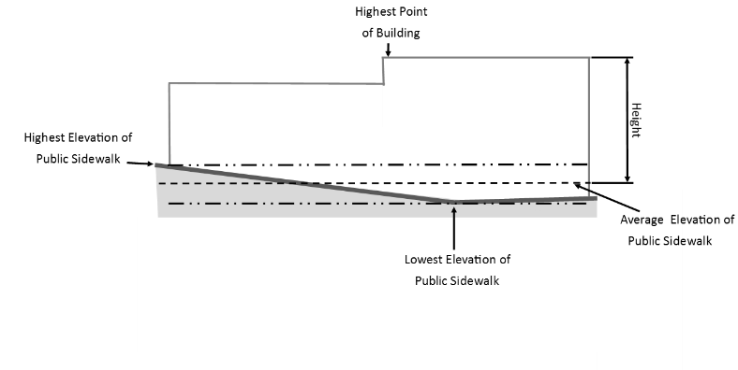
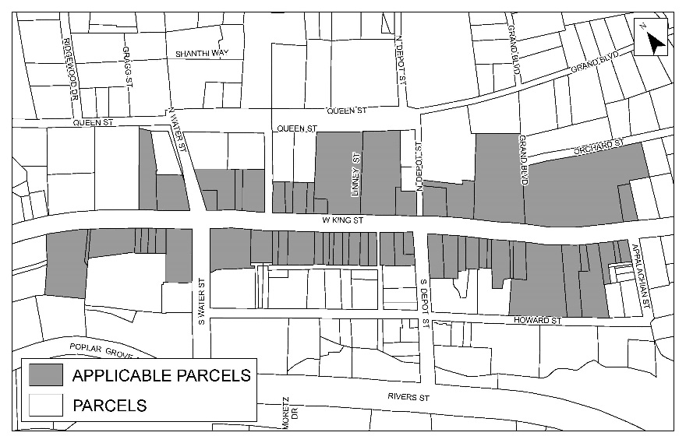

B1 - Building Height for Lots with Street Frontage

- Buildings which front on King Street as shown on the map above are limited to thirty feet (30’), as measured from the average elevation of the existing or proposed public sidewalk facing King Street to the highest point of the building or structure.
- Buildings which front King Street on corner lots shall be limited to thirty feet (30’), as measured from the average elevation of the existing or proposed public sidewalk facing King Street to the highest point of the building or structure.
- Buildings which front on King Street as shown on the map above and Howard Street are limited to thirty feet (30’) at the King Street elevation, and thirty-three feet (33’) at the Howard Street elevation. Building height shall be measured from the average elevation of the existing or proposed public sidewalk facing the street to the highest point of the building or structure subject to the limitations below. The building height limitation for the King Street elevation may extend horizontally from the building frontage on King Street toward Howard Street not more than 75% of the lot length.
- Buildings which front on King Street as shown on the map above and Queen Street are limited to thirty feet (30’) at the King Street elevation, and thirty-three feet (33’) at the Queen Street elevation. Building height shall be measured from the average elevation of the existing or proposed public sidewalk facing the street to the highest point of the building or structure. The applicable building height shall apply for each street and the building height limitation shall terminate at the midpoint of the lot.
- Buildings fronting streets in the B1 Central Business District, outside of the area governed by Subsection 14.19.04(F)(1) above, are limited to thirty-three feet (33’), as measured from the average elevation of the existing or proposed public sidewalk facing the street to the highest point of the building or structure containing the primary entrance.
- Buildings in the B1 Central Business District located on interior lots with no street frontage are limited to thirty-three feet (33’), with height being the vertical distance measured from the average elevation of the finished grade at the primary façade of the building to the highest point of the building or structure.
- Building Height Limitations:
- Flat roofs shall be capped by parapets of sufficient height to screen rooftop equipment and penthouses from view when standing at ground level twenty feet (20’) from the structure.
- The building height limitations for buildings on King Street governed by Subsection 14.19.04(F)(1) above shall include parapet walls.
- The building height limitations for buildings governed by Subsections 14.19.04(F)(5) and (6) above shall not include parapet walls so long as the parapet walls do not exceed 4’ above the maximum building height of thirty-three feet (33’). The height of parapet walls above 4’ shall be counted toward the building height.
- An existing building may not be demolished and replaced with a building of greater height unless approved under the Conditional District Zoning Map Amendment set forth in Article 9 herein.
- The height of existing buildings may not be increased unless approved under the Conditional District Zoning Map Amendment process set forth in Article 9 herein.
- Addition or modification of the features exempted in Subsection 14.03.07(G) do not trigger the requirement for the Conditional District Zoning Map Amendment process.
14.19.05 Occupancy: Unlimited family or up to 2 unrelated persons (see Section 14.04)

    - Appearance Standards
- The B1 Downtown Core and the B1 Downtown Interface Zoning districts are located within the Central Fire District which is regulated by the most recent edition of the NC Building Code. Applicants will be required to submit sufficient information during the zoning permit process for Staff to determine compliance of the proposed development with the requirements of the Central Fire District.
- Purpose: For purposes of this Section the term “historic” shall mean any building, building material, or feature fifty years or older as of May 1, 2018.
- Intent: When the Administrator is in doubt that a development meets the intent of the regulations of this Section, the permit shall be denied. The applicant may challenge this determination by appeal to the Town of Boone Board of Adjustment, in conformity with the procedures of Article 6.
- Applicability: This section is applicable to the primary and secondary facades and to any other publicly visible portions of building pursuant to UDO Subsection 25.01.01.
- Rhythm, Proportion, and Building Massing
- Rhythm and proportion are critical elements in an architectural composition, and it is vital that applicants understand and employ these principles when planning and designing additions and new construction. By following these principles, a project is more likely to achieve compatibility with the historic context of the downtown area. The principles of rhythm and proportion—which may refer to an individual building on one lot or several buildings that comprise a streetscape—are important to ensuring that renovations, additions and new construction projects are compatible with the surrounding neighborhood.
- Rhythm refers to the regular, or rhythmic, occurrence of building design elements such as windows and doors across a facade. Rhythm also refers to the pattern of buildings along a street.
- Proportion refers to a relationship between building design elements with respect to size and/or quantity. Proportion also refers to the height of a building in relation to its width and the dimensions of the structure in relation to the dimension of nearby buildings.
- Building massing refers to the general shape and size of a building. Building massing in the Downtown Districts should be similar to the massing patterns of buildings within the Downtown Core. These buildings have relatively modest massing. They have few, if any, building setbacks or projections and are almost always built straight up to the parapet, with the exception of recessed entries and architectural features listed herein.
- Applicants should utilize a segmented façade on larger buildings which breaks up the building’s façade such that it appears as several different buildings. Changes in the segmented façade should occur at the first floor tenant demising lines. Tenants may take up single or multiple segments. See photograph below for example.
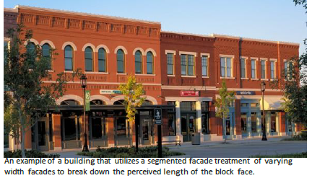
Photograph reproduced by permission of the City of Alpharetta, Georgia, Alpharetta Downtown Design Guidelines (Alpharetta, GA, 2017), 17.
- The segment widths shall be similar to the general widths of the buildings in the Downtown Core. See Graphic below.
Graphic 14.19.01-1 Segmented Treatment of Larger Building
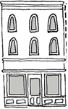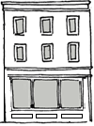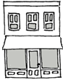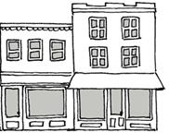

- Compatibility with Existing District. For purposes of this Article, when a development standard requires an element to be “similar or compatible” with Downtown historic buildings, the applicant shall reference the following group of buildings, herein after referred to as “desired downtown design” for the identified features:
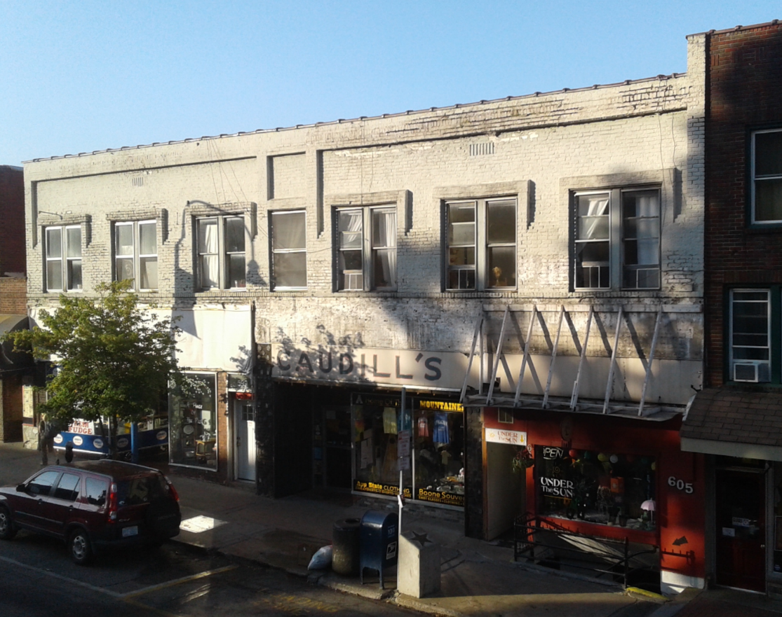
Graphic 14.19.06-2 Desired Downtown Design: 593-603 West King Street Identified Features: Original brick materials, brick detailing and coping; fenestration percentages
Graphic 14.19.06-3 Desired Downtown Design: 607 West King Street Identified Features: Original brick materials, brick detailing and coping; fenestration percentages; transom over door
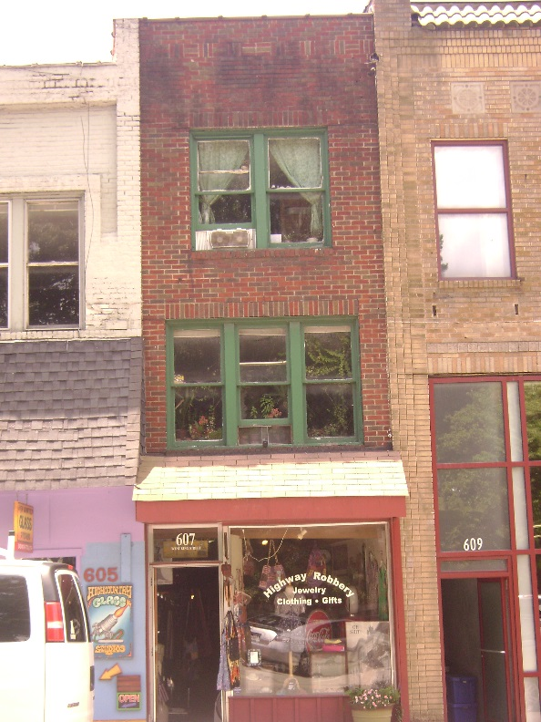
Graphic 14.19.06-4 Desired Downtown Design 627 West King Street Identified Features: Original brick materials, brick detailing and coping; medallions; fenestration percentages; transom over door
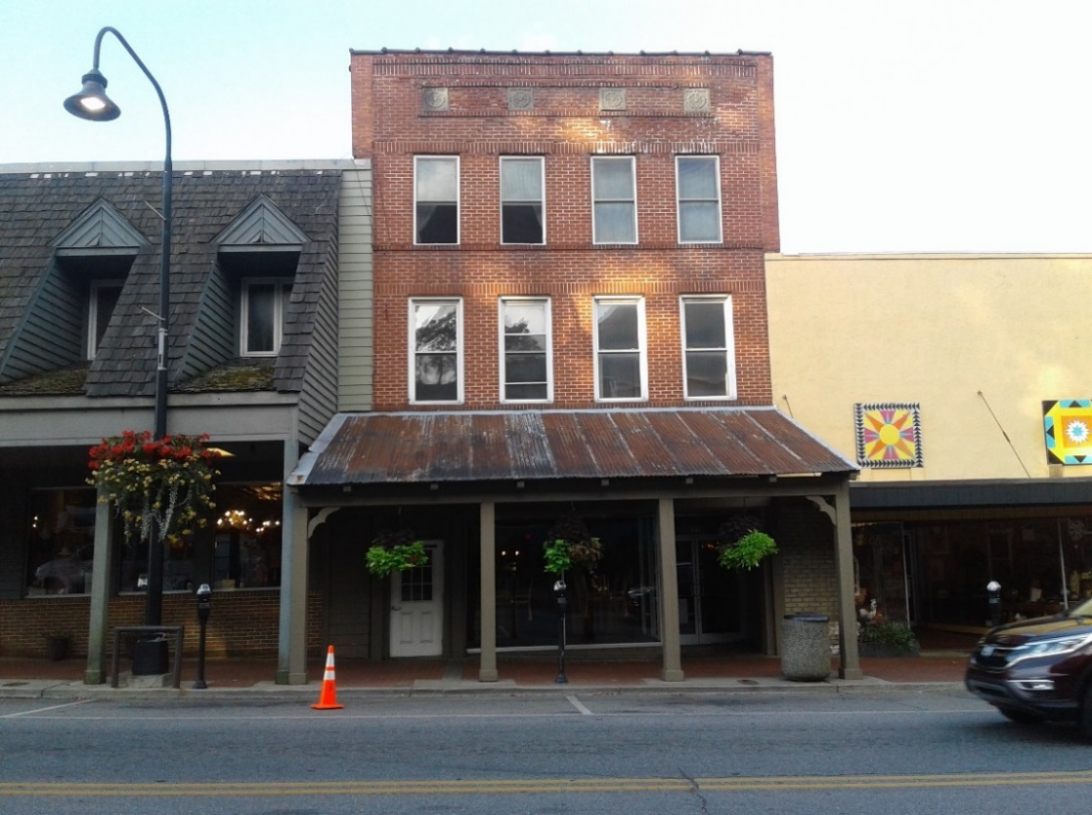
Graphic 14.19.06-5 Desired Downtown Design 630 West King Street Identified Features: Original brick materials, brick detailing; fenestration percentages; clerestory windows; doors; storefront window; awnings
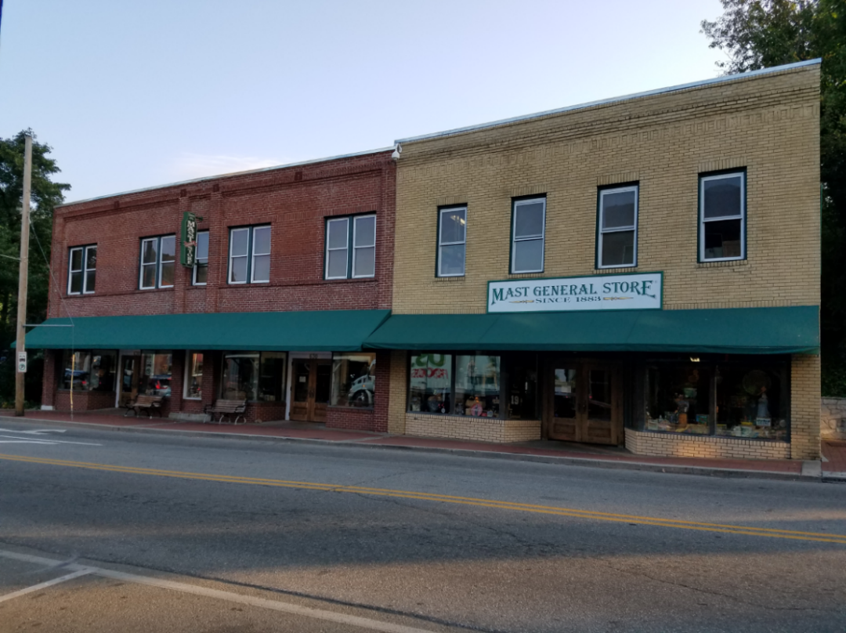
Graphic 14.19.06-6 Desired Downtown Design 659-661 West King Street Identified Features: Original brick materials and brick detailing; original concrete detailing; fenestration percentages; transom over door at 659 West King Street
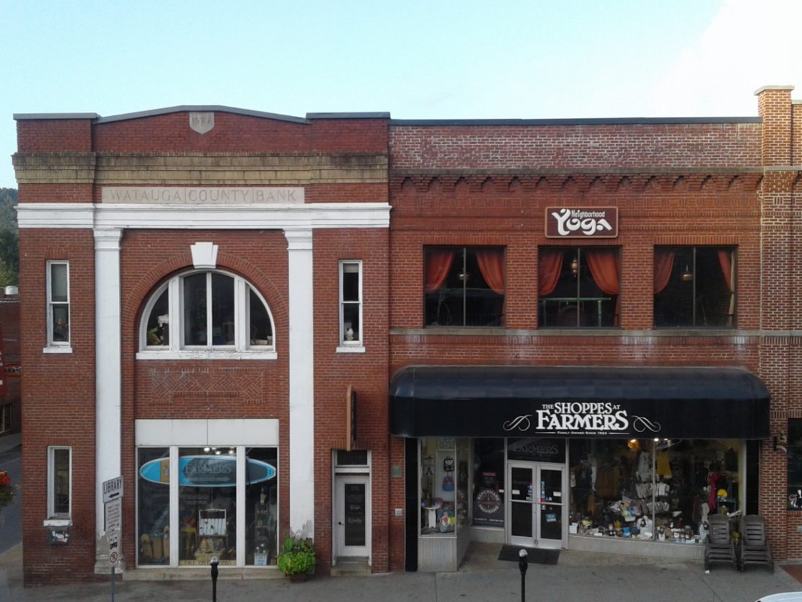
Graphic 14.19.06-7 Desired Downtown Design 671 West King Street Identified Features: Building demonstrates sympathetic renovation with brick materials, brick detailing, fenestration percentages, transoms over doors and awnings
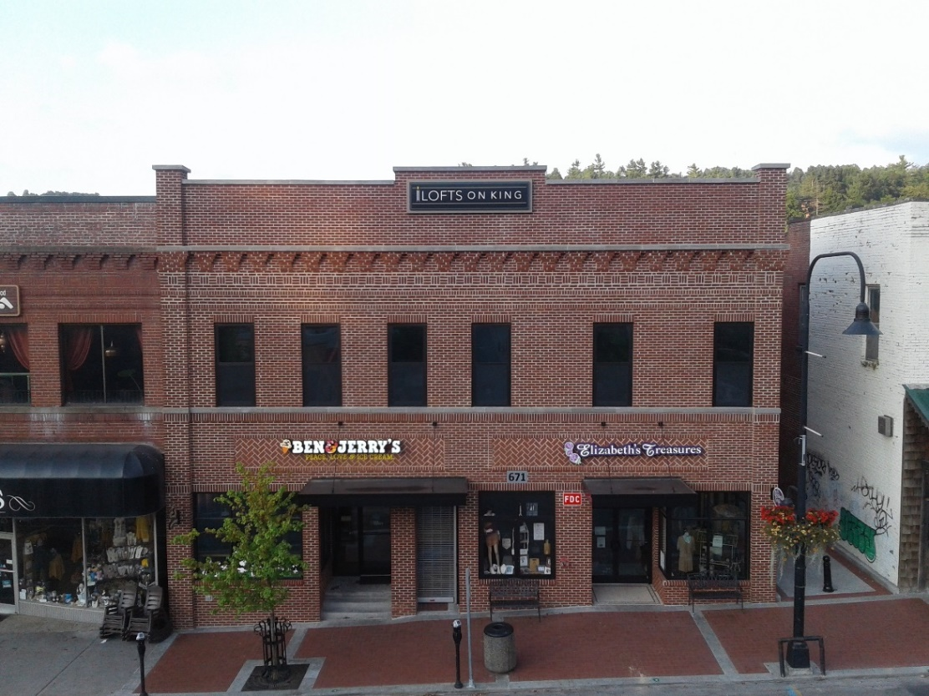
Graphic 14.19.06-8 Desired Downtown Design 680 West King Street Identified Features: Original stone material; window detailing
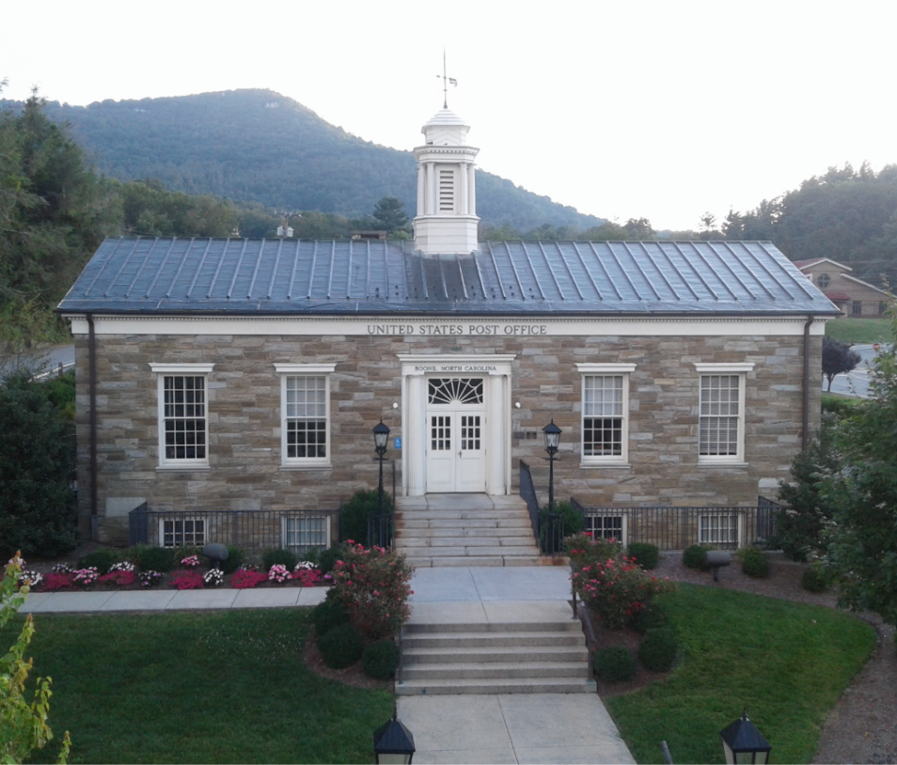
Graphic 14.19.06-9 Desired Downtown Design 685 West King Street Identified Features: Original brick materials, brick detailing; fenestration percentages; windows; and storefront window
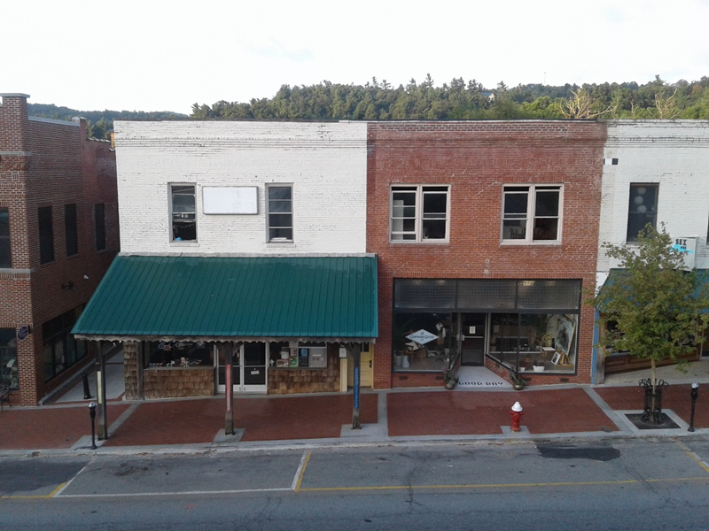
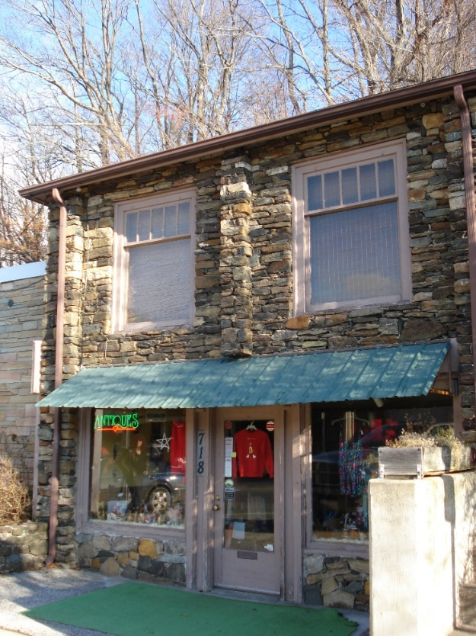
Graphic 14.19.06-10 Desired Downtown Design 718 West King Street Identified Features: Original stone materials, fenestration percentages; door; storefront window

- Design Standards for New Construction and Additions
- Purpose. The purpose of this section is to provide standards for the design of new building construction in the B1 districts in order to retain the historic context of the area while providing new opportunities for design. New building design must be sympathetic to existing buildings in the B1 Downtown Core, and respect the traditional qualities that make downtown unique, such as use of storefront detailing and choice of materials. Applicants shall use the design elements that pay tribute to what was historically present in Boone’s architecture. Compatible contemporary designs rather than historic duplications or replications are acceptable when new construction is considered.

- Architectural Features.
- Inclusion of the following architectural features supports the determination that a design is sympathetic or compatible with the area:
Graphic 14.19.06-11 Architectural Features
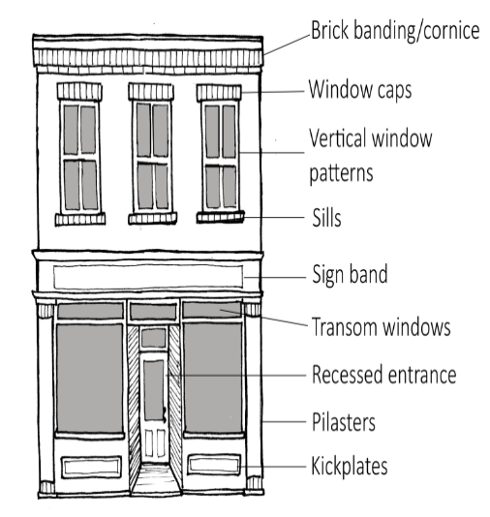
- First floor display windows.
- Recessed entrance doors where the door will not extend past the front of the building.
- Transoms or clerestory windows above doors and windows.
- Cornices
- Decorative Masonry Elements:
- Belt course: a course of bricks which runs the entire length of the façade and is laid in a pattern different to the stretcher or common course (examples include soldier or sailor course).
- Stone belt course: a course of stone (such as granite) which runs the entire length of the façade and is in a different material than the remainder of the façade.
- Masonry lintels or sills
- Quoins
- The features below will assist with contributing to the determination that a building is sympathetic or compatible but to a lesser degree than the list above:
- Kick plates when used as base to the windows and the entrance doors along a façade.
- Angled entrances on corners,
- Vertical window patterns and shapes between upper stories,
- Pilasters,
- Friezes and fasciae,
- Medallions,
- Sunbursts,
- Corbels,
- Decorative molding
- B1 Downtown Interface District. Additional contemporary architectural features allowed within the B1 Downtown Interface District that are not allowed within the B1 Downtown Core District include but are not limited to:
- Large glass windows on upper floors
- Metal detail and metal roof elements
- Accordion or garage-style window/doors
- Fenestrations
      - The rhythm, placement, size and proportion of window and door openings shall be designed to be similar or compatible with the desired downtown designs. See Subsection 14.19.06(G).
      - All buildings shall have storefront windows along all ground-floor level primary and secondary facades.
- There shall be a higher ratio of window to wall along the ground floor than the upper stories of the same building as detailed in Graphic 14.19.06-12.
- The bottom of ground floor windows must be no more than thirty inches (30”) above the sidewalk.
- The top of ground floor windows should be no less than eight feet (8’) above the sidewalk.
- The window to wall ratio should not exceed 75% of the ground floor façade area as detailed in Graphic 14.19.06-12 is measured from the average final grade of the façade to the roof for single-story buildings and to the lowest point of the second-story floor support for multi-story buildings.
- Any below-ground story which has a visible façade at the public sidewalk shall install windows similar in style and trim to the windows on the other levels of the same façade to the extent practical as to provide natural light into the below-ground story.
      - The window to wall ratio of an upper story shall meet the percentages outlined below. Parapets should not be included in the window to wall ratio for upper stories:
District | Upper Floor Window Coverage
B1 Downtown Core | 20-40%
B1 Downtown Interface | 20-60%

      - The use of clear or lightly‐tinted colored glass on windows and doors (minimum 70% VLT) is required. Spandrel glass is prohibited.

Graphic 14.19.06-12 Window to Wall Ratio
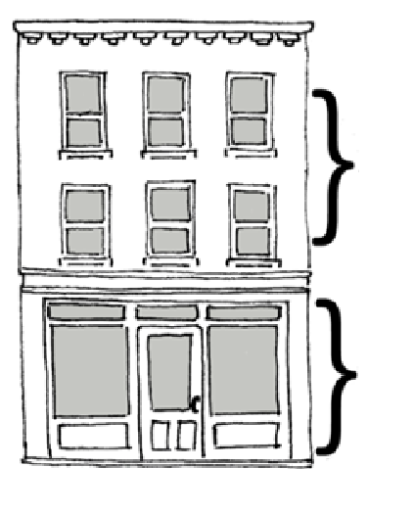
B1 Downtown Core: 20-40%
B1 Downtown Interface: 20-60%
75% or less
Note: Pursuant to Subsection 14.19.06(H)(3)(b)(i) above, there shall be more windows and a higher ratio of window to wall along the ground floor than the upper story.

      - Exterior Doors
- B1 Downtown Interface: All entrance doors off of the primary and secondary facades must be architecturally compatible/sympathetic with the storefront of the building.
- B1 Downtown Core: All entrance doors on the primary and secondary facades shall be made of a solid wood frame and must be architecturally compatible/sympathetic with the storefront of the building.
- Following are photographs of acceptable and unacceptable doors based upon use.

Acceptable Door Gallery for Any Use:
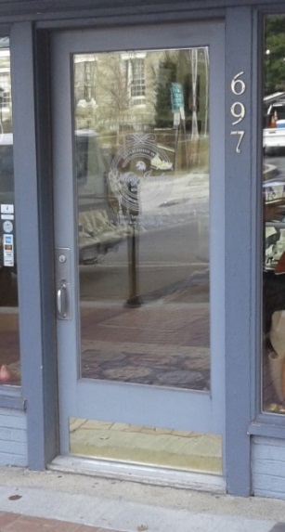 | 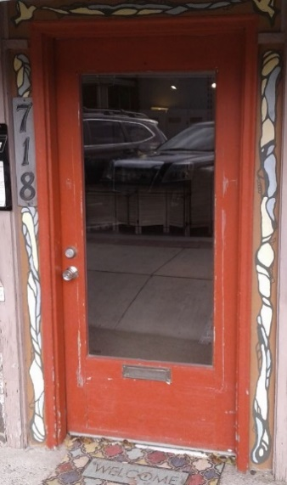 | 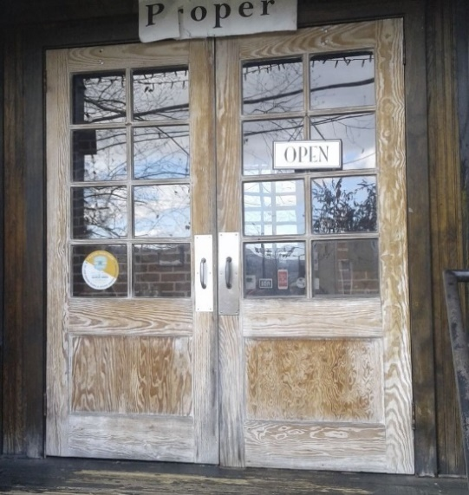
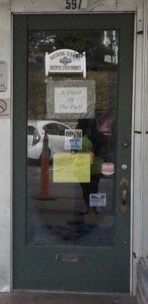 | 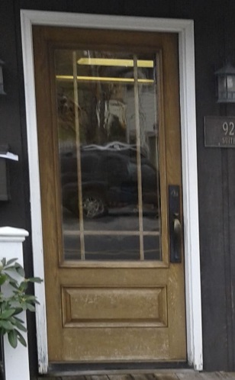 | 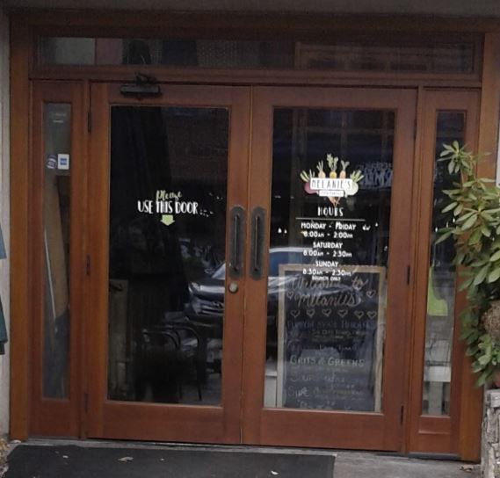
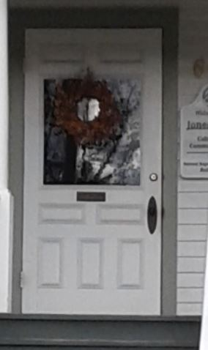 | 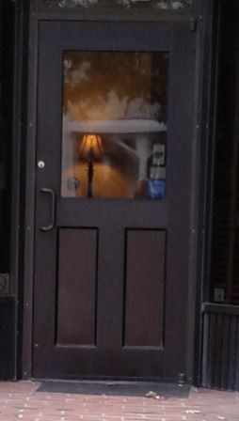 | 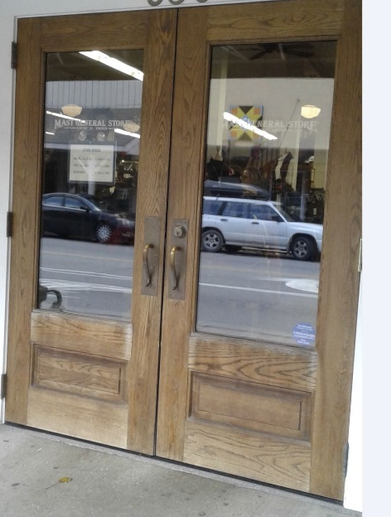
 | 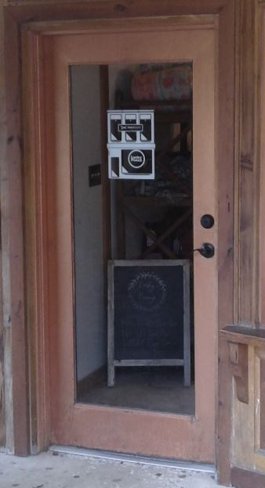 | 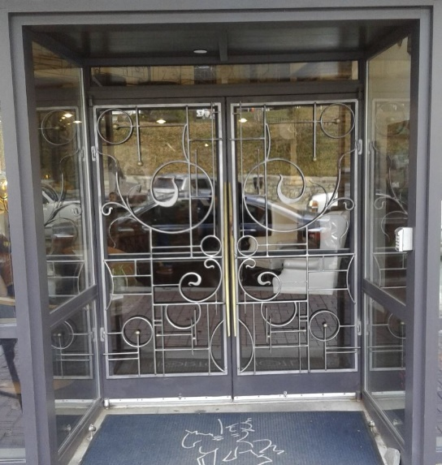

Acceptable Door Gallery for Office and Residential Access (directly into unit) :
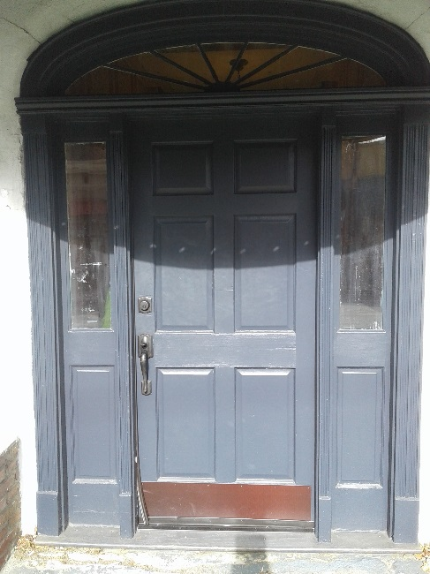
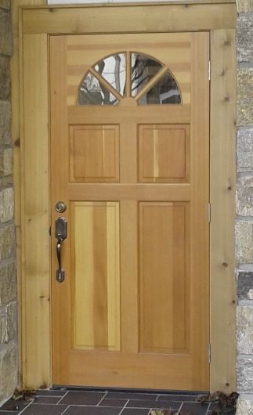
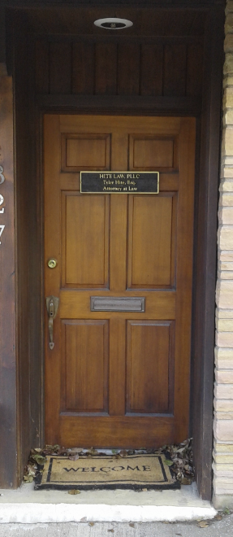

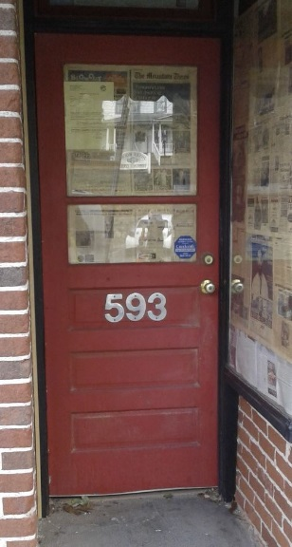
Acceptable Door Gallery for Residential Access (entrance into common area or directly into unit):
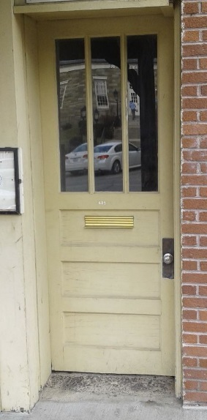

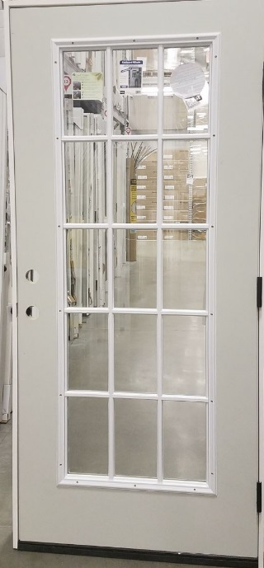
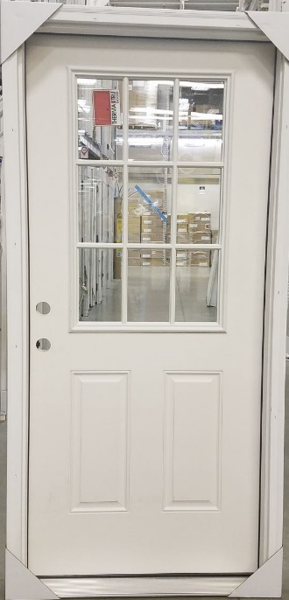
Unacceptable Door Gallery:
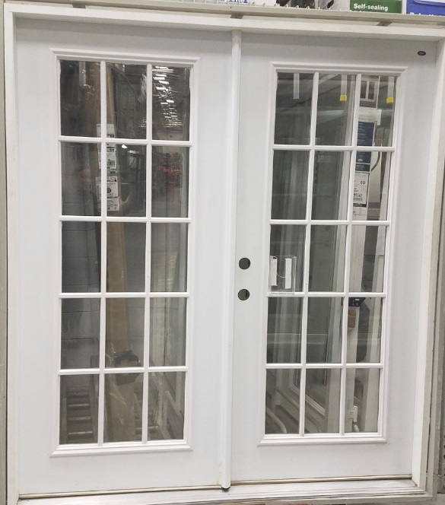
- Materials.
- Acceptable Materials: The use of materials that are similar or compatible in dimension, durability, and finish to the desired downtown designs. See Subsection 14.19.06(G).
- Acceptable Field Materials:
- Brick or stone, unglazed and unpainted
- Stucco finishes, but only (1) on non-primary or non-secondary facades; (2) the stucco finish must be similar or compatible to historic examples found in the B1 Downtown Core District, and (3) the stucco finish is not the primary building material.
- Acceptable Trim Materials:
- Brick or stone, unglazed and unpainted.
- Noncombustible wood details (Allowable wood detailed in the most recent NC Building Code)
- Metal (only on window and door trim)
- Copper
- Brick, Clay, or Ceramic Pavers
- Concrete and stone lintels
- Concrete, stone, or brick caps or cornices
- Prohibited Materials: The following exterior building materials are prohibited:
- Prohibited Field Materials:
- Fiber-cement,
- Metal,
- Vinyl,
- PVC composites,
- Fiber reinforced concrete (FRC),
- Glass curtain walls,
- Mirrored glass,
- Plexi-glass,
- Concrete blocks,
- Simulated brick or stone,
- Stacked stone with no mortar,
- Thin-stacked stone,
- Stucco finishes except as allowed in Subsection 14.19.06(H)(4)(a)(i)(B), and
- Dryvit, EIFS
- Prohibited Trim Materials (includes trim on doors and windows):
- Fiber-cement
- Metal (except on window and door trim),
- Vinyl,
- PVC composites,
- Fiber reinforced concrete (FRC),
- Concrete blocks,
- Simulated brick or stone,
- Stacked stone with no mortar,
- Thin-stacked stone, and
- Stucco finishes
- Any materials not listed are prohibited.
- Exceptions for prohibited materials. An otherwise prohibited material may be used in an addition if the applicant demonstrates that the same material is a historic material used on the existing building.
- Color
- Cornices, doors, door and window trim, awnings, canopies, and kickplates can be any color.
- Roofs: Historically, most of Boone’s downtown commercial buildings had flat roofs. This theme should be carried forward in new construction and additions using the following guidelines:
- The roof planes should be hidden from view on the façade, and rooflines should be decorated using historic decorative details. Use historic photographs and/or neighboring buildings as a guide.
- Terracotta tile or limestone roof coping is required in the B1 Downtown Core District and encouraged in the B1 Downtown Interface District.
- Residential roof types are prohibited.
- Pitched roofs are prohibited, with the exception of decorative roof elements such as clock towers and cupolas.
Graphic 14.19.06-13 Roofs

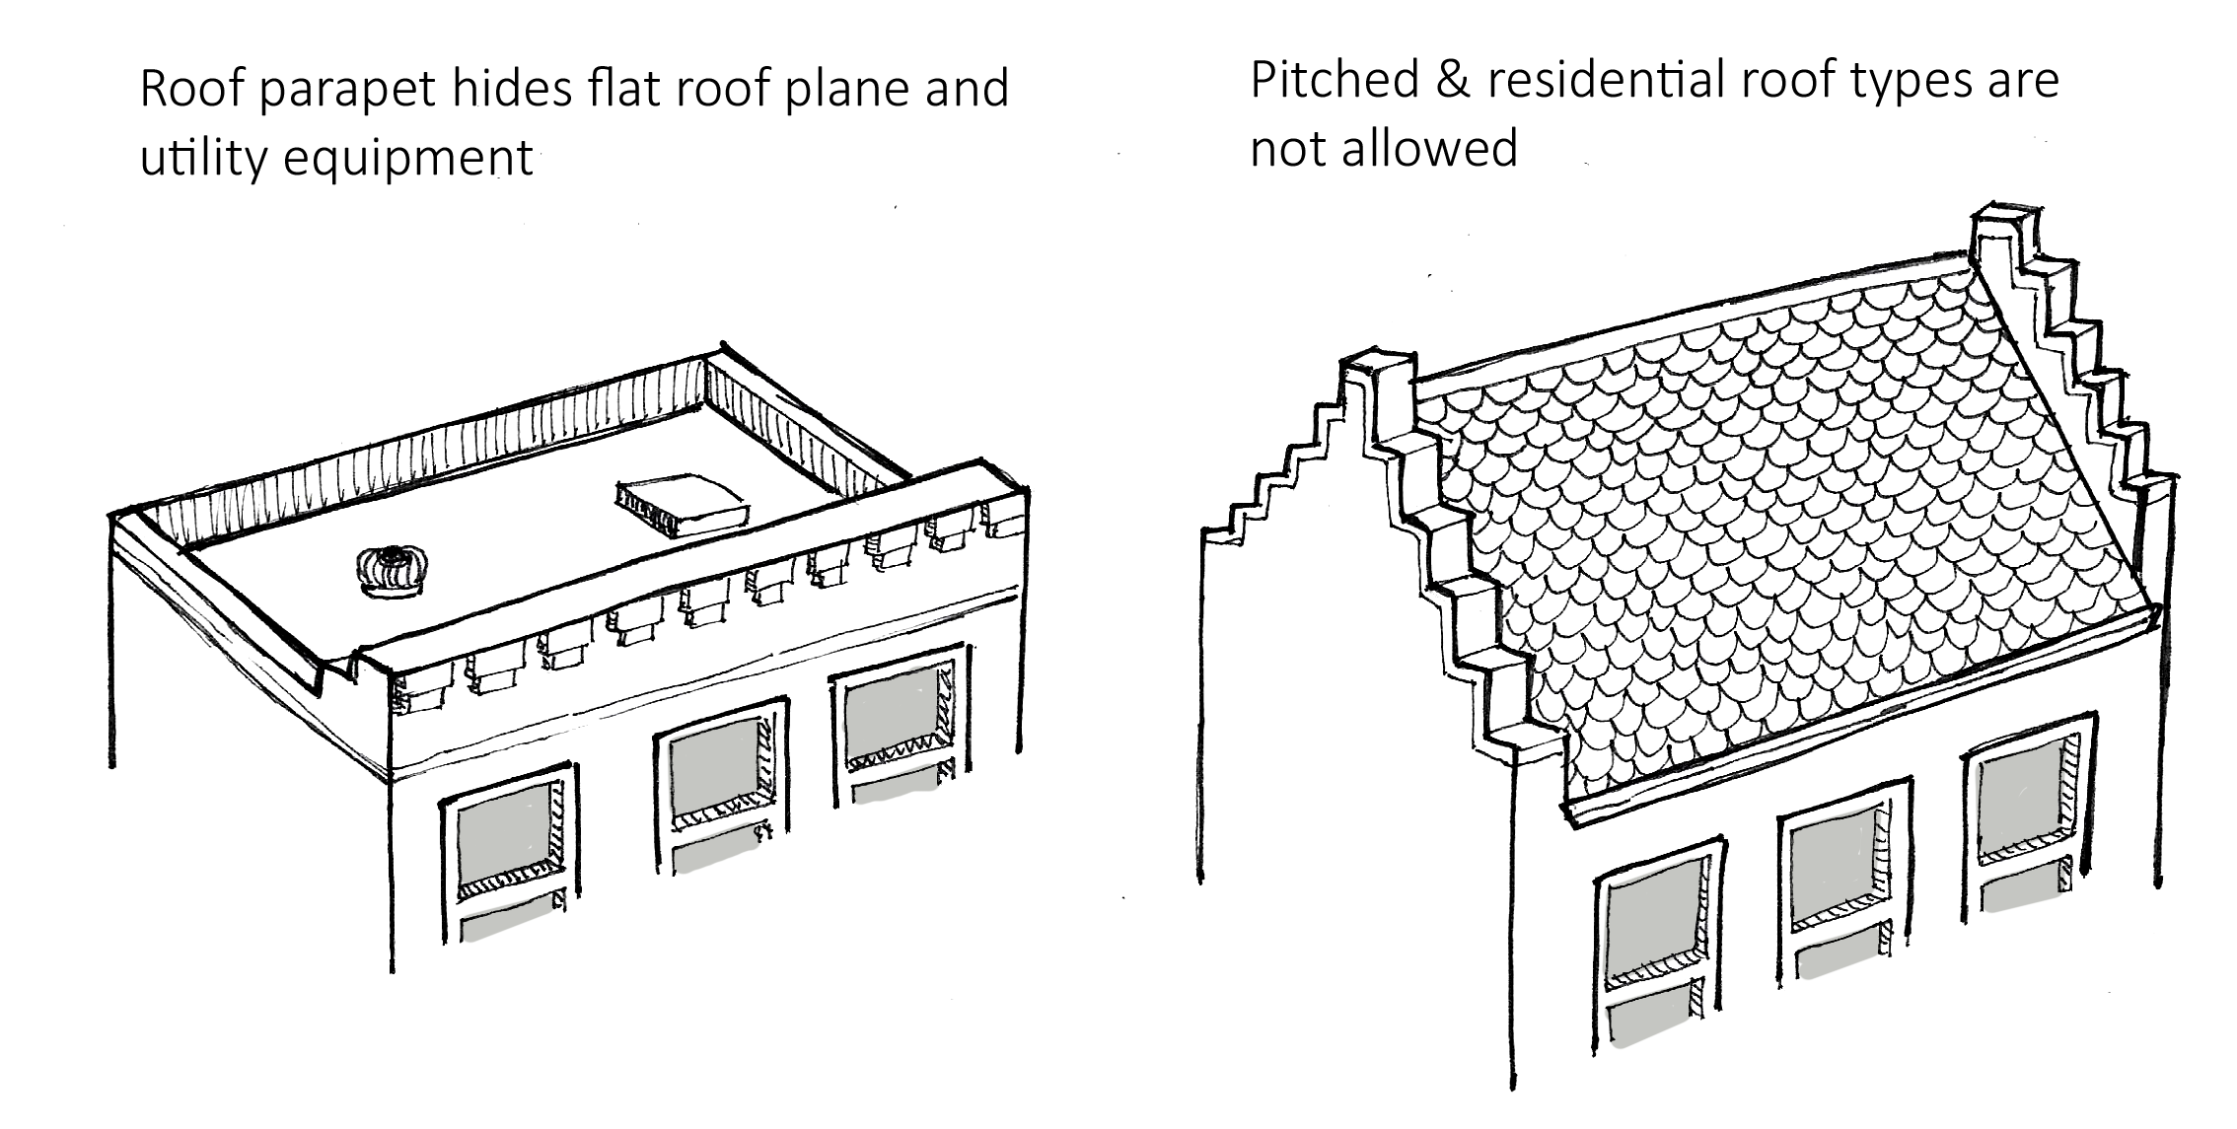

- Awnings and Canopies: Awnings and canopies shall be designed in relationship to the historic context of the surrounding district.
- B1 Downtown Core:
- Design should be complementary to the shape and color of the building façade.
- Awnings and canopies that are illuminated from within must be covered or finished with fully opaque materials.
- Acceptable awning and canopy styles are listed below (see Graphic 1 below):
- Metal frame covered with UV protected non-shiny cloth or canvas; or
- Cable‐hung awning or canopies
- B1 Downtown Interface:
- Design should be complementary to the shape and color of the building façade.
- Awnings and canopies that are illuminated from within must be covered or finished with fully opaque materials.
- Acceptable awning and canopy styles are listed below (See Graphics below):
- Metal frame covered with UV protected non-shiny cloth or canvas;
- Cable‐hung awning or canopies;
- Decorative wood frame awnings or canopies with copper roofing are allowed in the B1 Interface district; (allowable wood detailed in the most recent NC Building Code)
- Canopies with vertical supports are only allowed where the vertical supports do not encroach in the public way (sidewalk, alley, etc.).

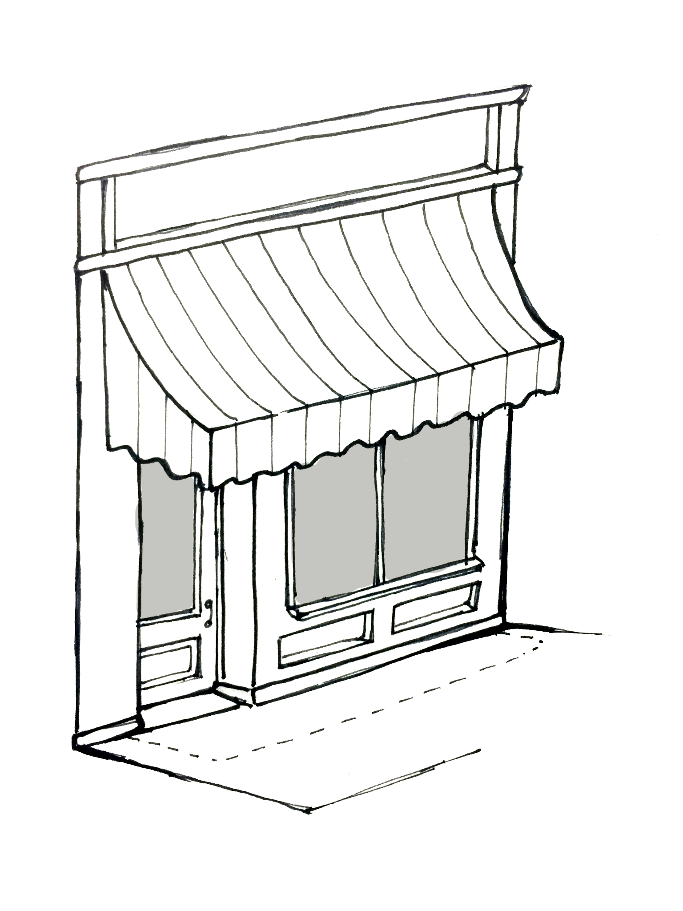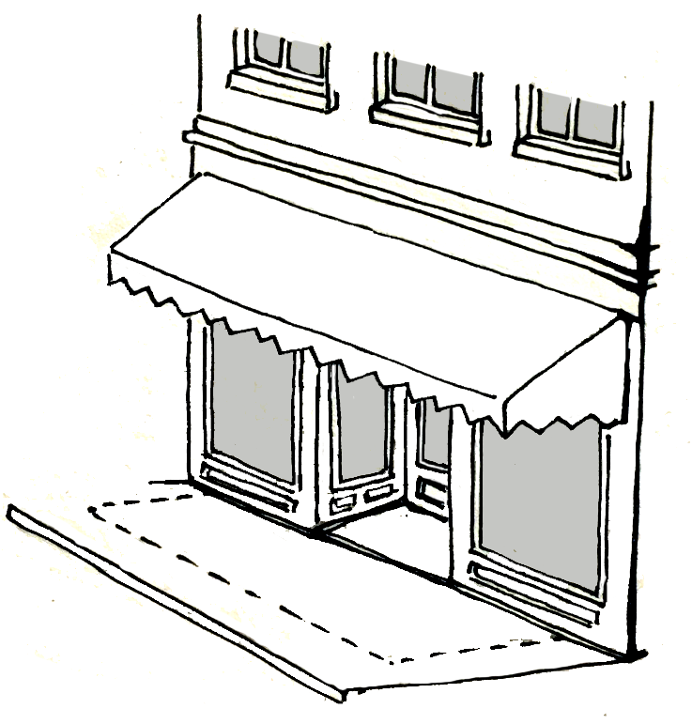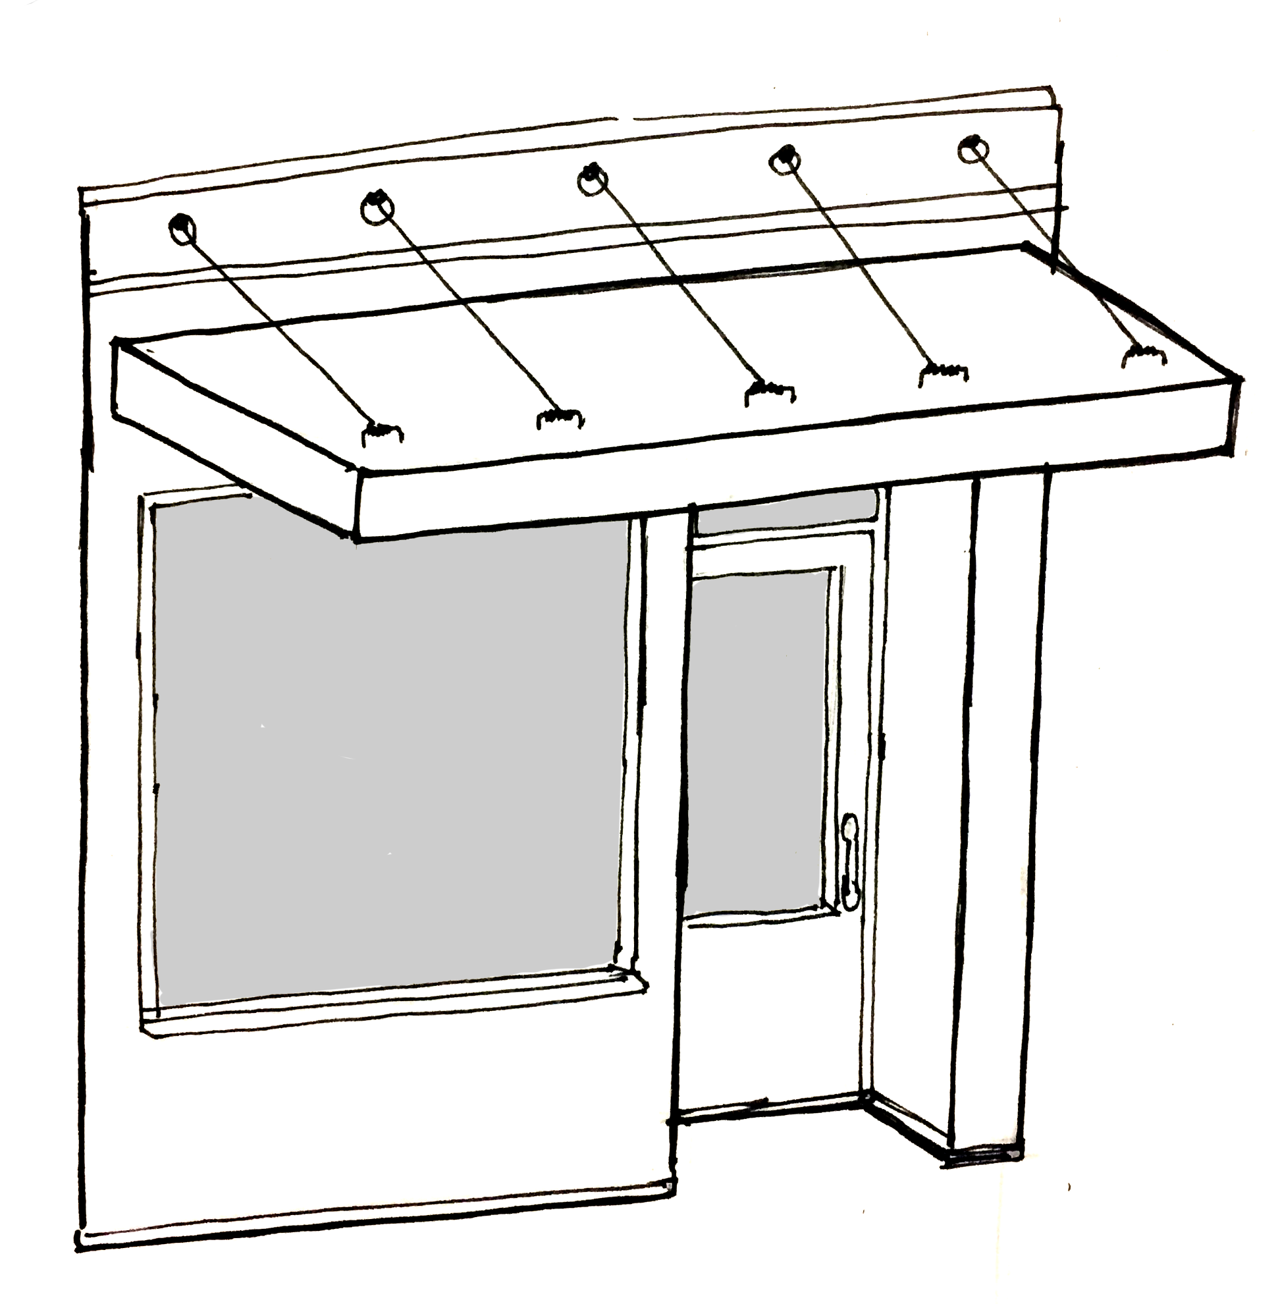
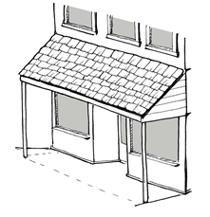
Graphic 14.19.06-14 Acceptable Awning and Canopy Types in B1 Downtown Core and B1 Downtown Interface
Graphic 14.19.06-15 Additional Acceptable Canopy Type in B1 Downtown Interface

- Additions:
- New additions should be designed and constructed so that the character‐defining features of a building are not radically changed, obscured, damaged, or destroyed. New design should always be clearly differentiated so that the addition does not appear to be part of the original building. Do not attempt to duplicate form, material, style, wall plane, roofline, cornice height.
- Exterior materials for additions shall be compatible with those on the original building.
- The addition should complement the scale, massing, materials, and window spacing of the adjacent building(s).
- Rooftop Additions: Rooftop additions to existing commercial block buildings, including those intended to accommodate elevator shafts, bars, decks, kitchen prep areas, social areas, or to otherwise enable recreational use of open rooftops, are generally not appropriate if any portion of the rooftop addition is visible from the street-level right of way adjacent to the primary facade.
- For buildings located on corner lots, additions should not be visible from the street-level secondary facade, either. In the vast majority of cases, this will mean positioning the addition within the one-third portion of the rooftop located closest to the non-primary or non-secondary facade of the existing building.
- Rooftop additions should never destroy or damage character-defining features of an existing building, and they should be designed to be compatible with both the size, scale, color, material, form, style, and character of the building on which they are erected. Rooftop additions should be subordinate to the existing building in size and design, and compatible with its massing, scale, materials, and features. Nevertheless, additions should be sufficiently differentiated as new elements from original components of the existing building.
- Rooftop additions should maintain the lowest possible profile in their construction, so that walkways, decks, seating areas, solar arrays, and similar components are built as close as functionally possible to the original roof surface of the existing building.
- The additions shall not be visible when viewed at eye level (5’-6" from grade) from the opposite side of the right-of-way adjacent to the primary façade (directly in front of the building; for corner properties, said additions shall also not be visible when viewed at eye level (5’6” from grade) from the opposite side of the side of the right-of-way adjacent to the secondary façade directly in front of the secondary facade.
  - When a building on a corner lot has more than one secondary façade, this standard shall only apply to the secondary façade with the higher level of vehicular traffic.
- Design Standards for Renovation of Existing Buildings.
- Purpose: A building may need renovation for a number of reasons. A building may be in poor condition, or may have been insensitively remodeled in the past. Similarly, certain changes may be desired in order to add either modern conveniences to a building or to bring the building up to current building code standards. Renovations to existing buildings shall be consistent with guidelines set forth herein.
- Applicants should exercise caution when undertaking renovations of buildings and building facades within the B1 Districts because once a nonconforming material or feature has been removed, the applicant will only be able to proceed with new materials and features which meet the requirements of this Section. Renovations are prohibited if they will destroy historic features or otherwise preclude subsequent preservation efforts.
- Distinctive or historic materials, features, finishes, construction techniques or examples of building craftsmanship of a building shall be retained and preserved. The removal of distinctive materials or alteration of features, spaces and spatial relationships that characterize a property shall be prohibited.
- Applicants shall identify, retain, and preserve masonry features that are important in defining the overall historic character of the building (such as, but not limited to: walls, brackets, railings, cornices, window and door surrounds, steps and columns), as well as decorative ornament and other details, such as tooling and bonding patterns, coatings, and color.
- Applicants shall identify, retain and preserve wood features that are important in defining the overall historic character of the building (such as, but not limited to: siding, cornices, brackets, window and door surrounds, and steps) and their paints, finishes and colors.
- Applicants shall identify, retain and preserve storefronts and their functional and decorative features that are important in defining the overall historic character of the building. The storefront materials (including wood, masonry, metals, ceramic tile, clear glass, and pigmented structural glass) and the configuration of the storefront are significant, as are features, such as, but not limited to: display windows, base panels, bulkheads, signs, doors, transoms, clerestory windows, kick plates, corner posts, piers, and entablatures. The removal of inappropriate, non-historic cladding, false mansard roofs, and other more recent, non-historic or insignificant alterations can help reveal the historic character of the storefront. If the original façade has been covered, then it should be uncovered if structurally feasible.
- Deteriorated historic features shall be repaired rather than replaced. Where the severity of deterioration requires replacement of a distinct feature, the new feature will match the old in design, color, texture, and where possible, materials. Missing features will be substantiated by documentary and physical evidence and shall only be replaced with new materials that match the existing historic material in composition, size, shape, texture, pattern, color and detail.
- Materials that are not visually compatible with the original façade, such as shiny metals, mirror glass, plastic panels, and vinyl windows or doors are prohibited, unless they can be documented through historic images or similar documentation.
- A historic material found on the existing building used for the same purpose or location will be found to be acceptable. Where necessary or desirable due to lack of historic materials, equivalency of alternative materials, or other reasons demonstrated to the satisfaction of the Administrator, applicants may use a compatible substitute material that reproduces the overall appearance and aesthetic of the historic material.
- Non-historic buildings (building built less than fifty years ago) in the B1 and buildings previously renovated or altered so that no historic features or materials remain shall be renovated in accordance with the standards set forth in Subsection 14.09.06(H).
- Non-historic materials or features may be repaired.
- Color
- Field Materials.
- If paint removal is not structurally feasible, painted field materials may be repainted.
- Non-painted field materials may not be painted.
- Paint color should be similar to the original color of the field material, the existing painted color of the field material, or a color from the Benjamin Moore Historical Collection series or equivalent.
- Trim Materials
- If paint removal is not structurally feasible, painted trim materials may be repainted.
- Non-painted trim materials may not be painted.
- When previously painted brick or stone trim, such as window lintels or sills must be repainted, paint color should be similar to the original color of the field material, the existing painted color of the field material, or a color from the Benjamin Moore Historical Collection series or equivalent.
- All other cornices, doors, door and window trim, awnings, canopies, and kickplates can be any color.
- Awnings and Canopies:
- B1 Downtown Core: Awning and canopies shall only be allowed in cases where their use can be historically documented in relationship to the historic context of the existing building.
- Design should be complementary to the shape and color of the building façade.
- Existing awnings and shed roof canopies on historic properties should be evaluated for their historical accuracy. In those cases where they are not appropriate, they should be removed and the original building façade appearance and orientation restored.
- Shed roof canopies are not historically appropriate to downtown Boone and are prohibited in renovations.
- Awnings and canopies that are illuminated from within must be covered or finished with fully opaque materials.
- Acceptable awning and canopy styles are listed below (see Graphic 1 Acceptable Awning and Canopy Types in the B1 Downtown Core and B1 Downtown Interface):
- Metal frame covered with UV protected non-shiny cloth or canvas; or
- Cable‐hung awning or canopies
- B1 Downtown Interface: Awning and canopies should only be installed in cases where their use can be historically documented in relationship to the historic context of an existing building and/or the surrounding district.
- In these instances, their design should be complementary to the shape and color of the building façade.
- Existing awnings and shed roof canopies on historic properties should be evaluated for their historical accuracy. In those cases where they are not appropriate, they should be removed and the original building façade appearance and orientation restored.
- Shed roof canopies are not historically appropriate to Boone and are prohibited in renovations.
- Awnings and canopies that are illuminated from within must be covered or finished with fully opaque materials.
- Acceptable awning and canopy styles are listed below:
- Metal frame covered with UV protected non-shiny cloth or canvas;
- Cable‐hung awning or canopies;
- Decorative wood frame awnings or canopies with copper roofing are allowed in the B1 Interface district; (allowable wood detailed in the most recent NC Building Code)
- Canopies with vertical supports are only allowed where the vertical supports do not encroach in the public way (sidewalk, alley, etc.).
- Exterior Doors
- Original exterior doors historic to the building shall be repaired and retained.
- The reuse of historic hardware and locks is encouraged.
- Renovations to facades shall retain recessed door areas or recreate recessed door areas, if historically appropriate, to the extent practicable.
- Renovations which require new doors or replacement of doors on the primary or secondary facades shall meet the standards set forth in UDO Subsection 14.09.06(H)(3)(e).
- Fencing
- Decorative fencing is permissible within the B1 downtown districts. Decorative fencing does not refer to the screening elements required for solid waste and recycling enclosures, HVAC units or similar items.
- Materials:
- Chain link, solid, barbed, razor wire, plastic, cloth, or electrified fences are prohibited in the B1 zoning districts.
- Materials may be of coated aluminum, wrought iron, or welded steel.
- Solid masonry pillars are allowed if made of the same brick or rock used on the principal structure.
- The fence must be installed with a decorative side facing away from the façade.
- Height:
- Fences placed fifteen feet (15’) or less from any public way including streets, sidewalks, alleys, and greenways shall not exceed forty-two inches (42”) in height and shall be screened with evergreen planting materials so that no more than ½ of the surface area will be visible from the public way.
- Fences over fifteen feet (15’) from any public way including streets, sidewalks, alleys, and greenway may not exceed six feet (6’) in height and shall be screened with evergreen planting materials so that no more than ½ of the surface area will be visible from the public way.
- Retaining Walls
- All publicly visible retaining walls within a B1 zoning district shall be faced with brick or rock material that is compatible with material on the principal structure. Retaining walls may not be faced with any kind of simulated brick, stone, or rock, or with concrete.
- Retaining walls within fifteen feet (15’) of the public sidewalk are prohibited in the B1 Downtown Core zoning district.
- Retaining walls within fifteen feet (15’) of the public sidewalk in the B1 Downtown Interface zoning district shall not exceed four feet (4’) in height.
- All other retaining walls shall not exceed six feet (6’) in height except for retaining walls in series where an eight foot (8’) landscape buffer has been installed in front of the wall. In those cases, the wall may increase to a maximum height of eight feet (8’).
- Buildings located near the top of site retaining walls shall be set back a minimum of four feet (4’) horizontally from the top of the retaining wall.
- Landscape buffer required:
- A series of two (2) or more retaining walls must have a minimum four foot (4’) landscaped buffer between each wall. See Graphic below.
- Retaining walls in series which collectively exceed twelve feet (12’) in height shall have a minimum of one (1), eight foot (8’) wide landscape buffer, between the first two (2). Retaining walls which are separated by a building, a road, or a parking area shall be exempt from this requirement. See Graphic below.



6’ Max. Height

4’ Buffer
8’ Buffer
8’ Max. Height

Graphic 14.19.06-16 Retaining Wall Buffers
Dash lines indicate building, road, parking or other element.

This wall may be a retaining wall.
4’ Min.
Can’t exceed 4’ in height when within 15’ of public sidewalk in B1 Downtown Interface.

- The landscape buffer as described above shall contain at a minimum the number of plantings as described in Table 26.07 Retaining Wall Landscape Buffer Standards. Number of plantings are based upon the linear measurement of the retaining wall. These buffers shall be maintained in accordance with the provisions of Section 31.12.
Graphic 14.19.06-17 Retaining Wall Landscape Buffer Standards
 | 4’ Landscape Buffer  26.07(F)(1) | 8’ Landscape Buffer  26.07(F)(2)
Total Number of Plants per 100 linear feet (Minimum) | 30 | 10
Number of shrubs (at least 75% shall be evergreen) | 25 | -
Number of evergreen trees | - | 7
Number of small deciduous trees | 5 | 3

- Landscaping: Development within the B1 zoning districts is exempt from the landscape standards set forth in UDO Article 31 except all development must comply with UDO Section 31.02 General Screening Standard, the requirements as set forth in UDO Sections 31.12 Compliance and Maintenance and 31.13 Preservation of Existing Trees and Vegetation and Appendix B in its entirety.
- B1 Downtown Core: The following landscape requirements apply within the B1 Downtown Core:
- Each development is required to provide street trees in accordance with the approved Downtown Streetscape Plan.
- Full landscape buffers are required where a lot in the B1 Downtown Core abuts a lot in another zoning district (except for B1 Interface and U1). These landscape buffers shall meet the requirements set forth in UDO Sections 31.04, 31.05 and 31.06 and Appendix B.
- No portion of any vehicular surface area shall be further than sixty feet (60’) from the trunk of a large deciduous tree.
- B1 Downtown Interface: The following landscape requirements apply within the B1 Downtown Interface:
- Applicants are required to provide large deciduous trees within the area set aside for the street setback and for any space dedicated to plaza space or landscaped greenspace at a rate of one (1) tree per every twenty-five (25’) linear feet with a minimum of two (2) trees per street frontage in accordance with the approved Downtown Streetscape Plan. Trees must be placed in areas which contribute to the overall health of the trees.
- Full landscape buffers are required where a lot in the B1 Downtown Interface abuts a lot in another zoning district (except for B1 Historic Core and U1). These landscape buffers shall meet the requirements set forth in UDO Sections 31.04, 31.05 and 31.06 and Appendix B.
- No portion of any vehicular surface area shall be further than sixty feet (60’) from the trunk of large deciduous tree.
- Utilities
- All utilities are required to meet the standards set forth in UDO Article 22 Utilities in addition to the standards set forth herein.
- Utility meters and vents, , should be located where they are not visible or the least publicly visible. Locations in order of acceptability are as follows:
- Any façade that is not considered a primary- or secondary-façade.
- Secondary-facades.
- Primary-facades for renovated buildings only.
- Utility meters and vents are only allowed on the primary façade of renovated buildings when it is impossible to place the utility meters and vents on any other façade.
- Unless prohibited by NC Building Code, utility meters and vents should be painted to match or blend with the color of the building or surroundings.
- Exterior mechanical and/or HVAC equipment:
- Preferred location shall be the roof.
- For those not located on the roof the equipment shall follow the location guidelines set forth in Subsection 14.09.06(M)(2) above and shall be screened in accordance with UDO Subsection 31.06.05.
- Installation of any utility shall not obscure or cover windows or any other distinguishing architectural features.
Article 24 Parking
….
24.04.04 Exceptions in the B1 Downtown Core District. Development in the B1 Downtown Core district is not required to meet the requirements of this Article, and will be construed as conforming to the requirements of this Article; provided, however, that (i) this exception does not apply to multi-family residential uses(s), and (ii) this exception applies with respect to motor vehicle parking and loading/unloading areas, and does not apply with respect to bicycle parking.
…
Article 34 Definitions
Awning
A shelter projecting from and supported by the exterior wall of a building constructed of non-rigid materials on a supporting framework.

Colonnade
A range of columns that supports a string of continuous arches or a horizontal entablature.

Column
A supporting pillar consisting of a base, a cylindrical shaft, and a capital on top of the shaft. Columns may be plain or ornamental.

Cornice
A cornice is the finished edge of the roof where it meets the exterior wall, of varying sizes, sometime plain, but often decorative and marked by brackets, dentils, medallions or some other decorative feature.

Fenestration
The arrangement of windows and doors on the façade of a building.

Finish
The visual characteristics including color, texture, and reflectivity of exterior materials.

Plaza Space
A pedestrian oriented urban open space which is predominately hardscaped. Plaza spaces should include manicured landscaping and pedestrian oriented amenities, such as benches, and should connect the building to the public sidewalk. Plaza spaces should be at or near the same grade as the sidewalk or the street.

Pilaster
A shallow, non-structural rectangular column, attached to, and projecting only slightly from, a wall surface.

Pillar
A structural support, similar to a column, but larger and more massive, and often without ornamentation. Pillars can be round or square in section, and are most often made of brick, stone, cement, or other masonry, although substantial wooden timbers can be formed into pillars.

Transom
A narrow window, sometimes hinged at the top, positioned over a doorway or larger window.

Sailor Course
A sailor course is similar to the soldier course but with the wide edge facing out. It is used for decorative effects (vertical, long, wide).

Sill
The flat horizontal bottom piece of a window or door, often of wood, but sometimes of stone.

Soldier Course
A soldier course is one in which bricks are laid standing on end with the narrow edge facing out. This type of course is sometimes used for decorative effects over door and window openings (vertical, long, narrow).

Stretcher Course
Brick laid flat with the long face parallel to the wall are called stretchers. When all the brick in the course are laid in this manner, it is called a stretcher course. (horizontal, long, narrow).

Window to Wall Ratio
A fraction of the total above grade façade area covered by fenestration.

Window to Wall Ratio = | Sq. Ft. of Window/Door Openings
 | Total Façade Area

